Creation:

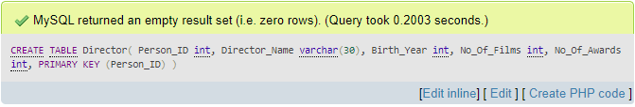

Fig 1.1: Query for Creating Relation ‘Director’

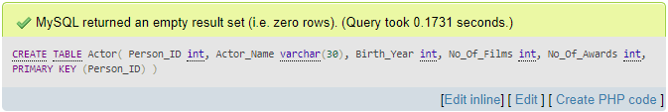

Fig 1.2: Query for Creating Table ‘Actor’

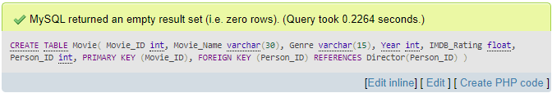

Fig 1.3: Query for Creating Table ‘Movie’

insertion:

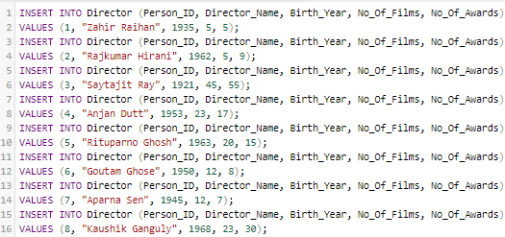

Fig 1.4: Query for Insertion in ‘Director’

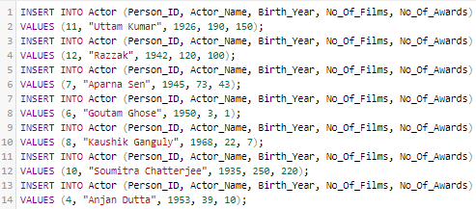

Fig 1.5: Query for Insertion in ‘Actor’

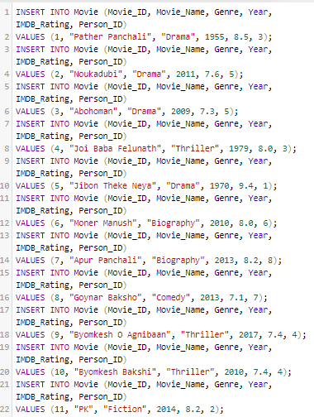

Fig 1.5: Query for Insertion in ‘Movie’